**Hotel Management System**

**Group 4**

**Apekshya | Kuwar | Sumit | Suyang**

**Table of Contents**

**Section 1: System Idea in a Nutshell 3**

**Section 2: Story Behind the Idea 4**

**Section 3: Information Offered to the Users 5**

**Section 4: Data Stored by the System 6**

**Section 5: Where is the Data coming from? 7**

**Section 6: The Target User 8**

**Section 7: Similar Systems 9**

**Section 8: Benefit to the Users 10**

**Section 9: Diagrams and Visual/Logical Design 11**

**Section 10:Conclusion 12**

# Section 1: System Idea in a Nutshell

The hotel management system will include a user interface, real-time booking system, user profiles, customer service, and analytics reporting functions. The user interface provides information on room availability, promotions, and hotel services, and integrates the hotel database for querying. The booking system supports real-time booking and secure payment, and the user profile function facilitates the storage of user preferences and historical records. Customer service provides answers to questions via email or chat support.

# Section 2: Story Behind the Idea

As the economy continues to grow and more countries worldwide open up visas to each other, more and more people have the opportunity to travel outside their homes to different regions for business. As the most popular accommodation mode, hotels have always played an important role in providing people with temporary warm and comfortable housing. However, due to the uneven management mode among different hotels, some hotels can’t provide proper services to customers. Also can’t cope with the large number of orders in the housing season. Our team understands that hotel management is not a small science, the manager needs to consider many different things, the customer service must be micromanagement, such as room cleaning, different booking methods, checkout, etc. Some universities even set up special professionals in hotel management. Thus in this assignment, our team will focus on the two systems of online booking and checking, helping hotels develop an online booking system that is easy to manage and use to deal with a large number of customers.

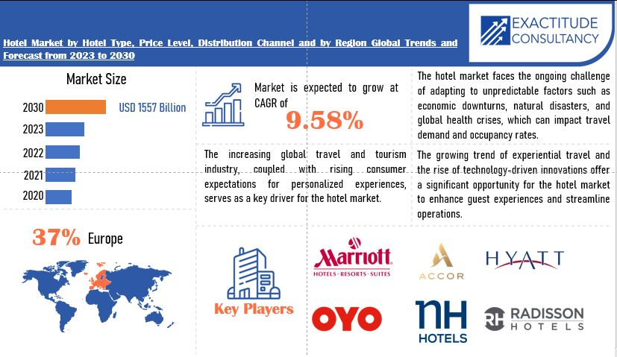

Figure 1

# Section 3: Information Offered to the Users

Our hotel management system will serve two groups in this assignment: which are Customers and hotel managers.

For Customers:

* + Real-time room availability: Customers can view the hotel's current available housing types and prices. This will help them choose an appropriate room according to their budget.
  + Online booking: Customers can use their device to book the room they want directly on the website, which includes their choice of room type, check-in time, and departure time. This helps customers get the room they want in advance and plan their trip better.
  + Booking history: Customers can view and manage their past and upcoming bookings.
  + Check-in notifications: The system will send reminders for check-ins and guide Customers on the check-in procedure.

For Hotel managers:

* + Room management: The Hotel manager can track which room is available, or using rooms, and upcoming check-ins.
  + Booking management: The system will allow hotel staff to monitor current reservations, cancel or modify bookings, and generate reports.
  + Check-in processing: The hotel front desk can help customers check into the hotel according to the online booking information registered in the system. This will save both of them a lot of time.
  + Payment status: Administrators can view payment history and outstanding balances for booked customers.

# Section 4: Data Stored by the System

The data that our system will store consists of two main aspects. Hotel room type, room number, room status, etc. The user-side booking time, name and contact information, number of visitors, and type of room booked.

# Section 5: Where is the Data coming from?

The room reservation information we have comes from a reservation system within our company that monitors room availability, reservation dates, and user choices. The system syncs with a calendar tool to provide up-to-date availability information. Information is securely stored in a database, guaranteeing precision and confidentiality. This information enables us to efficiently handle room availability and offer users a smooth booking experience. We use virtual data for the discussion, these results are for reference only.

# Section 6: The Target User

1. Hotel Staff:- Front desk staff for guest services, check-ins, and check-outs.   
- Housekeeping personnel for scheduling cleanings and managing rooms.   
- Food and beverage personnel for bar and restaurant operations.   
2. Hotel Management: - Supervisors and managers who are responsible for managing personnel, money, and operations.   
3. Reservation Agents:- Employees that deal with reservations and client questions.   
4. Finance and Accounting Teams:- Employees in charge of financial reporting, payroll, and budgeting.   
5. IT Support Staff:- The technical teams who maintain and debug the system are known as IT Support Staff.   
6.Users:- End users who might utilize the system to make reservations, check in or out, or use hotel services.   
7. Marketing Teams:-Employees that use data analysis to inform marketing plans and visitor interaction.   
Every group needs distinct features designed to function in different way.

# Section 7: Similar Systems

Airline reservation Systems: Similar to hotel reservations, airline reservation systems allow users to check flight availability, seat information, and fares in real-time and make reservations. The system supports online payments and personalization Settings such as flight alerts and seat preferences.

Car Rental Reservation System: The car rental system provides vehicle availability, model information, rental prices, and user reviews. Users can book their cars online, choose where to pick up and drop them off, and make secure payments. The system also supports the saving of user preferences and the viewing of history.

Event/ticket booking systems: such as a concert, expo, or movie ticketing systems, users can view event seat availability, ticket prices, offers, and book instantly. The system offers online payments and allows users to save personal preferences and booking history.

# Section 8: Benefit to the Users

1.Convenience: It will be easier for the users to compare, view the available rooms according to their requirements and most importantly book rooms online without their physical presence as people have a busy schedule these days.

2.User Reviews and Ratings: Users can view the ratings and reviews and decide whether to choose or not to choose as sometimes the online expectations can’t be met in real world.

3.Promotions and Discounts: Users can have access to the available offers, discounts and package deals which will be most suitable for them, and they won’t miss out on the discounts and offers.

5.Security: Users can use secure payment methods which will help them gatekeep their financial details and make safe transactions during the booking process.

6.Mobile Access: As most of the today’s world people are familiar with mobile phones and gadgets, so they can use online websites and apps on go.

7.Customer Service: Users can get online customer service without being physically present and get help with any issues and questions related to bookings.

# Section 9: Diagrams and Visual/Logical Design

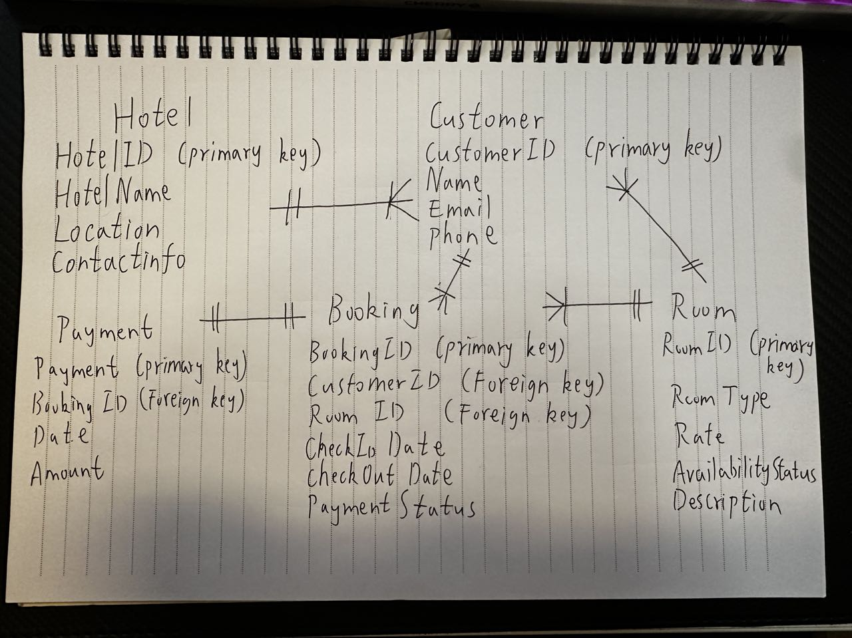

# Section 10: Conclusion

In summary, our team designed a management system for online booking and checking of hotels during this assignment. This system is only a very small part of the hotel management system, in order to improve it in the future we also need to put more efforts, invest more energy and time, but we all believe that it is worth it.Everyone works really well, and everyone was very involved in the process. Suyang completed Section2,3,9,10. Kuwar completed section4,5. Apekshya completed section1,8. Finally, Sumit completed sections 6 and 7.and we hope this system can help hotels operate more conveniently.

# Reference:

Figure 1 :

Exactitude Consultancy. (2024, January). *Hotel Market Report*. <https://exactitudeconsultancy.com/reports/35759/hotel-market/>